Tutorial 1 ER model concepts

Objectives:
Revise concepts of ER modeling
Use of MS Visio (alternatively www.draw.io) as a tool for creation of ER models in UML notation
Develop ER models based on case studies

Revision questions
- What is the difference between terms: Entity Type and Entity Occurrence, Relationship Type and Relationship Occurrence? Provide examples of each.
- Describe what attributes represent in an ER model and provide examples of simple, composite, single-value, multi-value, and derived attributes.
- Describe what the multiplicity constraint represents for a relationship type. How does multiplicity represent both the cardinality and the participation constraints on a relationship type?

For each of the following case studies you will need to produce ER diagrams using UML notation in MS Visio or draw.io online tool.
University database
A university database contains information about professors (identified by social security number, or SSN) and courses (identified by courseid). Professors teach courses. For each of the following cases draw ER diagram:
- Each professor should teach only one course and each course is delivered by one professor. Each professor must teach a course and each course must have a professor assigned to it.
- Each course could be delivered by one or more professors but each professor could teach only one course.
- Each course could be delivered by one or more professors and each professor could teach one or more courses. Some professors might not teach any courses.

Company database
A company needs to store information about employees (identified by ssn, with salary and phone as attributes), departments (identified by dno, with dname and budget as attributes), and children of employees (with name and age as attributes).
Employees work in departments; each department is managed by an employee. A child must be identified uniquely by name when the parent (who is an employee; assume that only one parent works for the company) is known. We are not interested in information about a child once the parent leaves the company.
Draw an ER diagram that captures this information.

Notown Records
Notown Records has decided to store information about musicians who perform on its albums (as well as other company data) in a database.
- Each musician that records at Notown has an SSN, a name, an address, and a phone number. Poorly paid musicians often share the same address, and no address has more than one phone.
- Each instrument used in songs recorded at Notown has a unique identification number, a name (e.g., guitar, synthesizer, flute) and a musical key (e.g., C, B-flat, E-flat).
- Each album recorded on the Notown label has a unique identification number, a title, a copyright date, a format (e.g., CD or MC), and an album identifier.
- Each song recorded at Notown has a title and an author.
- Each musician may play several instruments, and a given instrument may be played by several musicians.
- Each album has a number of songs on it, but no song may appear on more than one album.
- Each song is performed by one or more musicians, and a musician may perform a number of songs.
- Each album has exactly one musician who acts as its producer. A musician may produce several albums, of course.

Video rental company
The video rental company has several branches throughout the USA. The data held on each branch is the branch address made up of street, city, state, and zip code, and the telephone number. Each branch is given a branch number, which is unique throughout the company. Each branch is allocated staff, which includes a Manager. The Manager is responsible for the day-to-day running of a given branch. The data held on a member of staff is his or her name, position, and salary. Each member of staff is given a staff number, which is unique throughout the company. Each branch has a stock of videos. The data held on a video is the catalog number, video number, title, category, daily rental, cost, status, and the names of the main actors, and the director. The catalog number uniquely identifies each video. However, in most cases, there are several copies of each video at a branch, and the individual copies are identified using the video number. A video is given a category such as Action, Adult, Children, Drama, Horror, or Sci-Fi. The status indicates whether a specific copy of a video is available for rent. Before hiring a video from the company, a customer must first register as a member of a local branch. The data held on a member is the first and last name, address, and the date that the member registered at a branch. Each member is given a member number, which is unique throughout all branches of the company. Once registered, a member is free to rent videos, up to maximum of ten at any one time. The data held on each video rented is the rental number, the full name and number of the member, the video number, title, and daily rental, and the dates the video is rented out and date returned. The rental number is unique throughout the company.

Home work

Online Database research
Search in the internet for the relational, object relational, object oriented, and NoSQL DBMSs. Pay attention to supported features, if the DBMS is open source or commercial, latest release of DBMS, on what operating systems it might be used/installed, does the DBMS has multiuser support, could it be used as embedded DBMS.
Try to find out what projects/organizations use particular DBMS.
Based on your research develop a short report that will provide for each class of databases available DBMSs. Compare and contrast DBMSs that you have found based on their features. Try to identify the most popular DBMSs in each class.
You could use dbdb.io, wikipedia.org to find a list of DBMSs.

ER modelling
Draw ER diagram for the Video rental company case study.

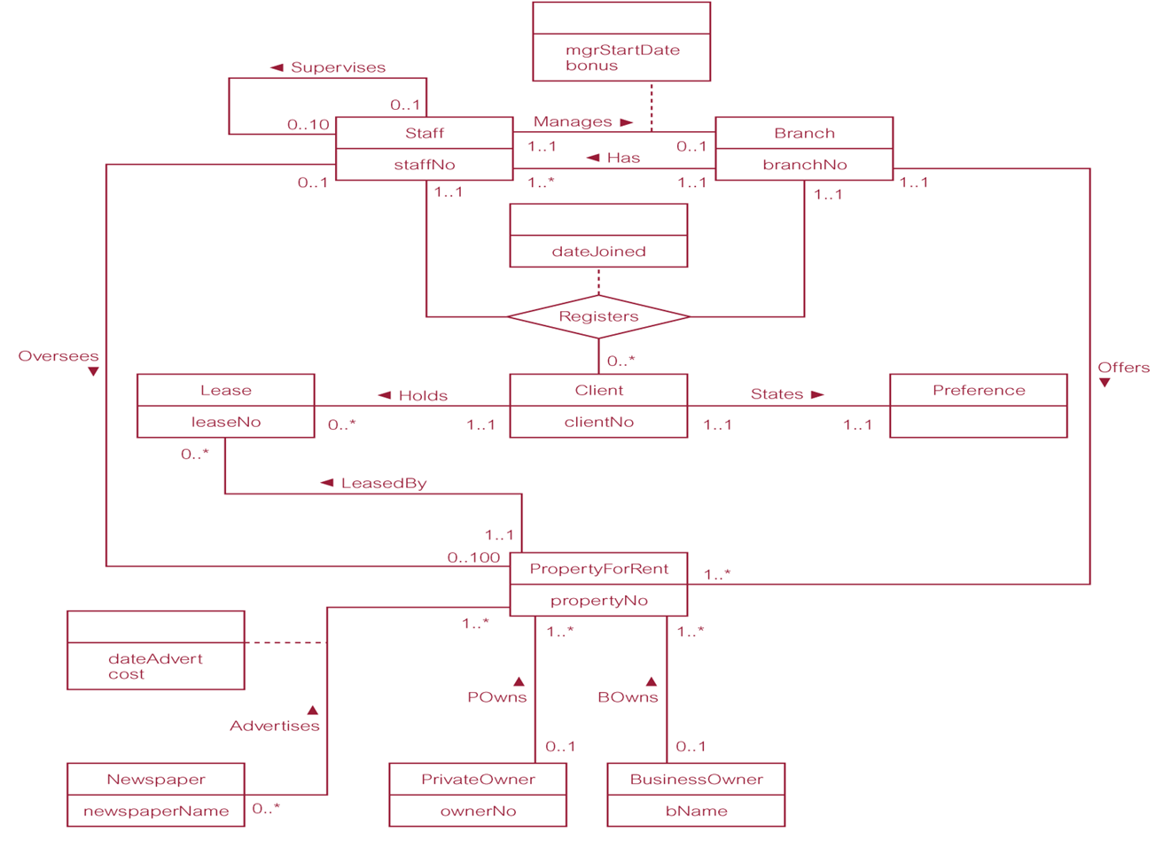
Appendix
UML diagram example

